IMPLEMENT CLASSIFICATION MODEL USING SVM AND COMPUTE EVALUATION METRICS

AIM:
To implement the Support Vector Machine (SVM) classification algorithm using Python to predict students' results based on hours studied, attendance, and assignments, and visualize the actual and predicted results using a graph.
ALGORITHM:
- Import the required libraries: Pandas, Matplotlib, and Scikit-learn.
- Load the dataset from the data.csv file.
- Select Hours_Studied, Attendance, and Assignments as input features.
- Select Result as the target variable.
- Split the dataset into training and testing sets.
- Create an SVM classifier using a linear kernel.
- Train the SVM model using the training dataset.
- Predict students' results using the testing dataset.
- Evaluate the model using accuracy, confusion matrix, and classification report.
- Convert the actual and predicted class labels into numeric values for plotting.
- Plot the actual results using blue dots and predicted results using red crosses.
- Display the graph with the title “SVM Classification”.

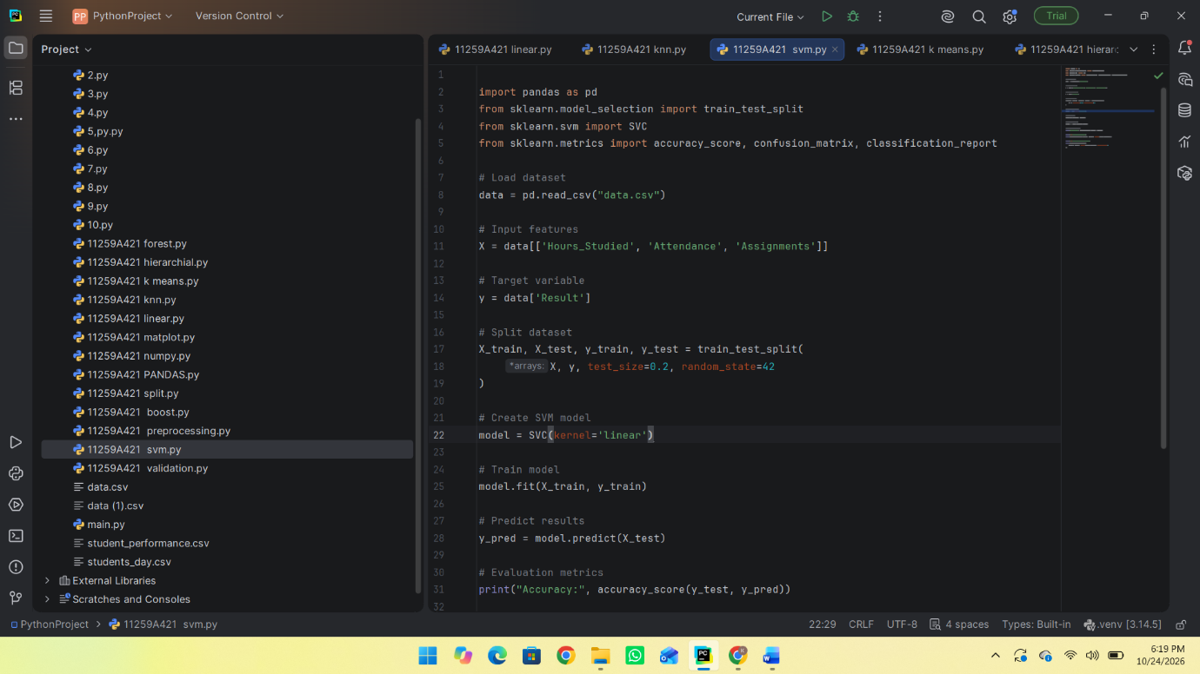
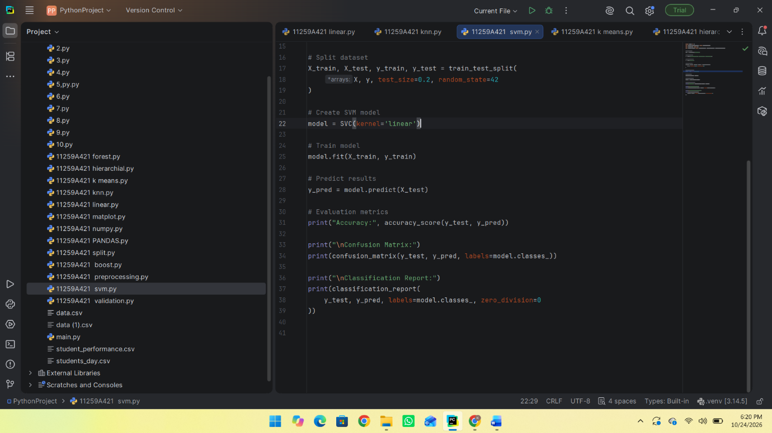
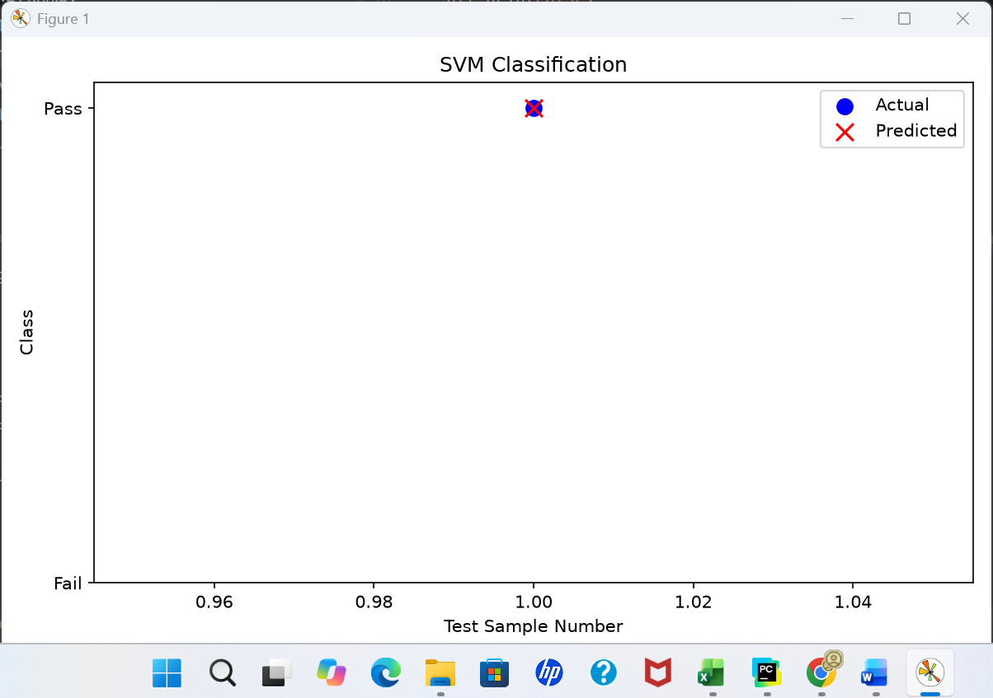
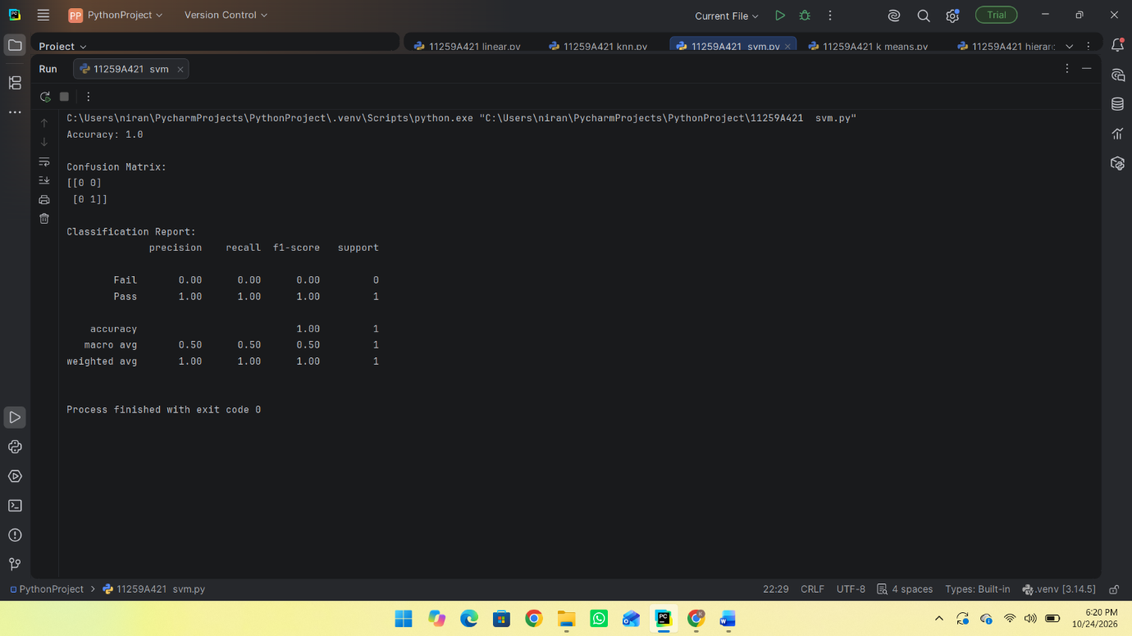

RESULT:
Thus, the Support Vector Machine (SVM) classification algorithm was successfully implemented using Python to predict students' results. The model's performance was evaluated using accuracy, confusion matrix, and classification report. A graph was plotted to compare the actual and predicted results.

